MMW (STC Board)

Block Diagram

**Motor Driver Board (STC12C5A60S2)**

**STM32 (Blue Pill)**

**Air724UG DTU**

**MQTT**

**Drop Sensor**

**Motors**

**Door Sensor**

**Temperature Sensor**

This version of MMW consists of three essential boards; an Air724UG Data Transmission Unit (DTU), an STM32F103C8T6 microcontroller (Blue Pill), an STC12C5A60S2 motor driver board (DB). The DTU receives command via MQTT and sends to the Blue Pill via UART with 8 data bits, and 1 stop bit. Blue Pill sends dedicated Hex data bytes to the DB via UART with 9 data bits, and 1 stop bit.

Wiring Diagram

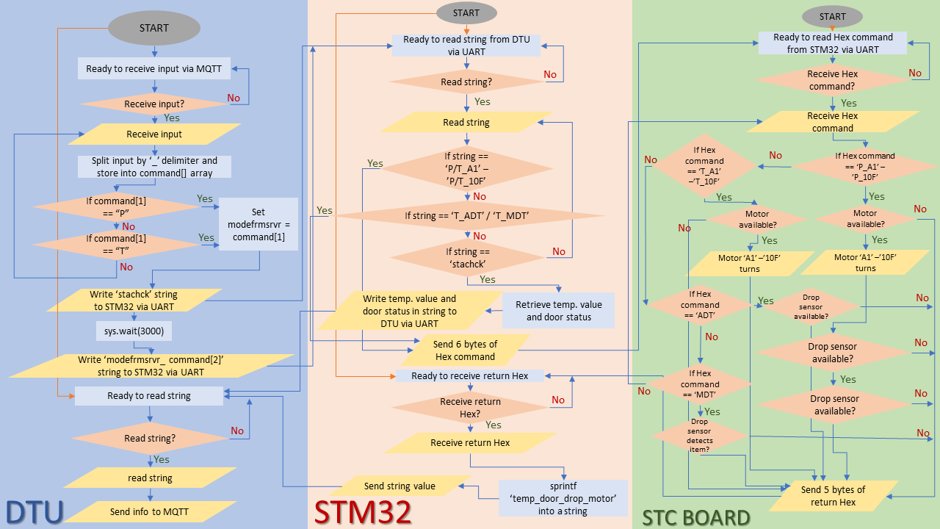Flowchart

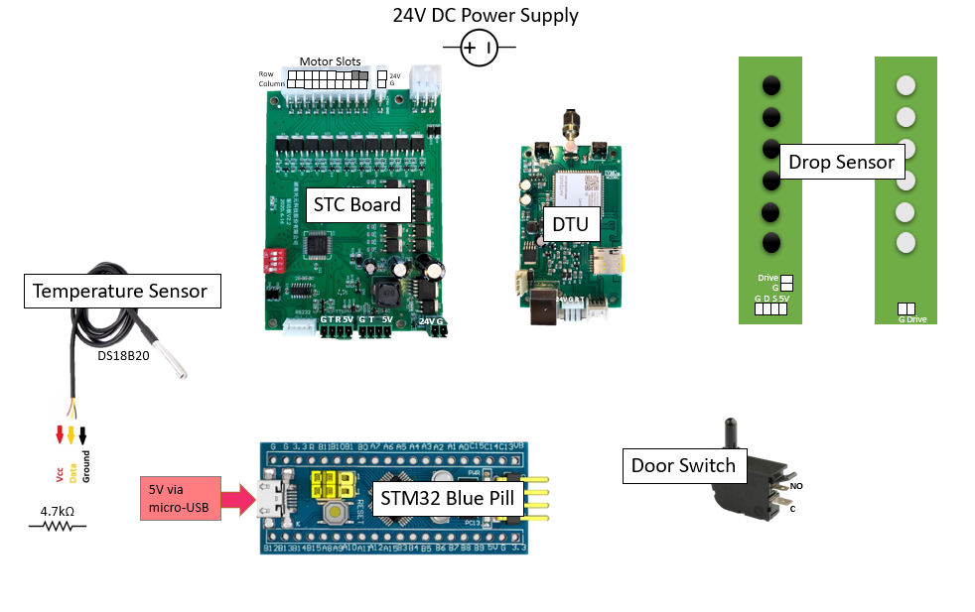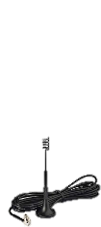

4G LTE Antenna

Input

Input command format: Mode_Command Type_Date_Count

Purchasing Mode:



* **P**: Purchasing mode. This mode is used when **customer** is purchasing item from vending machine. This mode will run specific motor and activate the working of drop sensor.
* **A1**: Command type for motors. Other command types available are:

Row A: A1, A2, A3,…….A9, 10A

Row B: B1, B2, B3,…….B9, 10B

Row C: C1, C2, C3,…….C9, 10C

Row D: D1, D2, D3,…….D9, 10D

Row E: E1, E2, E3,…….E9, 10E

Row F: F1, F2, F3,…….F9, 10F

* **09082022**: Date. Date format: DDMMYYYY
* **1**: Count.

Testing Mode:

* **T**: Testing mode. This mode is used by **technician** for testing purposes. Testing mode includes testing for single motor functionality, testing for motors functionality by row, testing for all motors functionality, testing for automatic drop sensor test, testing for manual drop sensor test, and retrieving current temperature and door sensor status.
* **Command Type**:
* Single Motor Testing:



Row A: A1, A2, A3,…….A9, 10A

Row B: B1, B2, B3,…….B9, 10B

Row C: C1, C2, C3,…….C9, 10C

Row D: D1, D2, D3,…….D9, 10D

Row E: E1, E2, E3,…….E9, 10E

Row F: F1, F2, F3,…….F9, 10F

* Motors testing by row:



Row A: RWA

Row B: RWB

Row C: RWC

Row D: RWD

Row E: RWE

Row F: RWF

* All motors testing:



* Automatic drop sensor testing:



* Manual drop sensor testing:



* Retrieving current temperature and door sensor status:



* **09082022**: Date. Date format: DDMMYYYY
* **1**: Count.

Data bytes command for driver board

|  |  |  |  |  |  |  |
| --- | --- | --- | --- | --- | --- | --- |
| **Check whether Motor (Slot) is present *Note that this command will not run the motor** |  |  |  |  |  |  |
| **Motor Command (Example with motor A1)** | 0xFB | 0x01 | 0x06(Row) | 0x0A(Column) | 0xXX | 0xFB |
| Check if there is connection *** |  |  |  |  | 0x00/01 |  |
| ***Return*** |  |  |  |  |  |  |
| Motor (Slot) is normal *** | 0xFB | 0X01 | 0x05 | 0X00 | 0XFB |  |
| Motor (Slot) not normal *** | 0xFB | 0X01 | 0x00 | 0X00 | 0XFB |  |

|  |  |  |  |  |  |  |
| --- | --- | --- | --- | --- | --- | --- |
| **Single Motor Dispensing** |  |  |  |  |  |  |
| **Motor Command (Example with motor A1)** | 0xFB | 0x02 | 0x06(Row) | 0x0A(Column) | 0xXX | 0xFB |
| Spiral cargo mode with Drop Sensor *** |  |  |  |  | 0x01 |  |
| ***Return*** |  |  |  |  |  |  |
| Motor not available *** | 0xFB | 0X02 | 0x00 | 0X00 | 0XFB |  |
| Object not detected (Item not dropping) *** | 0xFB | 0X02 | 0x02 | 0X00 | 0XFB |  |
| Object detected (Item dropping successful) *** | 0xFB | 0X02 | 0X05 | 0X00 | 0XFB |  |

|  |  |  |  |  |  |  |
| --- | --- | --- | --- | --- | --- | --- |
| **Test Motor Function * Note that this command will run the motor** |  |  |  |  |  |  |
| **Motor Command (Example with motor A1)** | 0xFB | 0x03 | 0x06(Row) | 0x0A(Column) | 0xXX | 0xFB |
| Test if Spiral cargo motor not connected *** |  |  |  |  | 0x11 |  |
| ***Return*** |  |  |  |  |  |  |
| Motor turning is normal *** | 0xFB | 0X03 | 0x05 | 0X00 | 0XFB |  |
| Motor turning not normal/ Not connected *** | 0xFB | 0X03 | 0x00 | 0X00 | 0XFB |  |

|  |  |  |  |  |  |  |
| --- | --- | --- | --- | --- | --- | --- |
| **Automatic Drop Sensor Test (availability)** |  |  |  |  |  |  |
| **Command to test whether the sensor is connected** | 0xFB | 0x04 | 0x00 | 0x00 | 0x00 | 0xFB |
|  |  |  |  |  |  |  |
| ***Return*** |  |  |  |  |  |  |
| Ok *** | 0xFB | 0X04 | 0x01 | 0X00 | 0XFB |  |
| Fail (Connection failure) *** | 0xFB | 0X04 | 0x00 | 0X00 | 0XFB |  |

|  |  |  |  |  |  |  |
| --- | --- | --- | --- | --- | --- | --- |
| **Manual Drop Sensor Test (functionality)** |  |  |  |  |  |  |
| **Command to test whether the sensor works fine** | 0xFB | 0x06 | 0x00 | 0x00 | 0x00 | 0xFB |
|  |  |  |  |  |  |  |
| ***Return*** |  |  |  |  |  |  |
| Ok *** | 0xFB | 0X06 | 0x01 | 0X00 | 0XFB |  |
| Fail (No item detected/ Connection failure) *** | 0xFB | 0X06 | 0x00 | 0X00 | 0XFB |  |

Example Input and Output

